Where, Precisely, are the Three Pyramids of Giza?

By Glen Dash, Glen Dash Foundation for Archaeological Research

[Revision of May 5, 2017]

Those wishing to study the monuments at Giza may be surprised to find out that there are few readily available maps fixing the locations of its three major pyramids to an accuracy of better than a meter. Flinders Petrie, in his landmark 1880-1881 study, did record the locations of all three pyramids, but unfortunately he used a coordinate system so arcane that it is difficult to work with today. In this paper, I will convert Petrie’s data into a modern coordinate system. Then I will combine Petrie’s data with more recent survey data to produce a map which locates the Pyramids of Giza with a accuracy of better than a meter.

Flinders Petrie’s Survey

Flinders Petrie began his survey at Giza by installing a series of control points, or “stations,” at the periphery of the plateau. (Figure 1) This outer ring of stations looped around the pyramids forming an irregular polygon. Inside the polygon, Petrie set more stations, placing a few on the pyramids themselves.

Petrie then measured the angles between stations. Figure 1 shows the sight lines he used. Once he recorded the angles, Petrie used a combination of mathematical and graphical techniques to solve for the distances between stations. For stations on bedrock, Petrie estimated he could calculate distances between stations with a “probable error” of 0.06 inches. For stations on more irregular ground, he estimated he could achieve an accuracy of two or three inches.

However, measuring the distance between stations is different than locating the pyramid corners. For example, Petrie was keenly interested in knowing the precise location of the corners of the Great Pyramid. Unfortunately, the corners are no longer there, having been hauled away for building material centuries ago. Petrie’s answer to the problem was to mount stations on the four sides of Great Pyramid where he found evidence of the original building lines. (Figure 2) Petrie recorded those stations, and then used a combination of mathematical calculations and geometrical arguments to locate the lost corners. Petrie published his results in his 1883 work, The Pyramids and Temples of Gizeh.

The Control Grid

Surveyors use a “survey control grid” to plot the points they record. A control grid can be oriented in any direction, but a cardinal orientation is often used. Any convenient point can serve as the grid’s origin. By modern convention, the distance to the north of the origin is called the “northing” (N) and distance to the east, the “easting” (E).

Petrie produced a survey control grid that met the standards of his day, but which is difficult for us to use today. He used “southings” and “westings” rather than northings and eastings, and he did not align his grid exactly with cardinal points. Petrie also did not use either feet or meters to record distance, but units of his own devising which work out to approximately 196.713 units to the inch.

The modern survey control grid we use at Giza is not Petrie’s, but one established by David Goodman and Mark Lehner in 1984-5 and known as the Giza Plateau Mapping Project (GPMP) control grid. (Figure 3) The GPMP grid is cardinally oriented with its origin set at the calculated center of the Great Pyramid. Following the usual practice among surveyors, Goodman and Lehner did not assign a value of N=0 and E=0 to this origin, but instead assigned it a value of N=100,000 and E=500,000 in order to avoid having to use negative numbers for places south and west of the origin.

In 2012 and 2015, the Glen Dash Foundation for Archaeological Research and Ancient Egypt Research Associates completed two surveys on the Giza Plateau. The 2012 survey, designated GDFS 2012, recorded the location of approximately 1500 points across the plateau. The survey of 2015 (GDFS 2015) mapped the base of the Great Pyramid in great detail. We used data from the latter survey to produced new estimates for the location, size and orientation of the Great Pyramid.
Converting and Comparing Petrie

Both our survey and Petrie’s used two bronze control points near the northeast and northwest corners of the Great Pyramid as stations. These control points, shown in Figure 2, were set in place by David Gill in 1874. Our common use of these two points gives us a way to compare the two surveys, and to derive a mathematical formula to covert Petrie’s data to GPMP coordinates. The table below shows the locations of the two Gill control points (now designated G1.1 and G1.4) as measured by the GDFS 2015 survey team (in GPMP coordinates) and as recorded by Petrie (in his own coordinates):

Location | GPMP Designation | GDFS 2015 |  | Petrie
 |  | Northing | Easting | Southing | Westing
NE Corner | G1.1 | 100115.803 | 500115.610 | 1880871 | 1381354
NW Corner | G1.4 | 100115.591 | 499884.148 | 1844679 | 3173572

In Appendix A, I use these two points to derive a formula to convert Petrie’s data to GPMP coordinates. The formula is:

$$\begin{aligned}N=\text{100362}\text{.}\text{353}−\frac{1}{\left(\text{196}\text{.}\text{713}∗\text{39}\text{.}\text{3700787}\right)}\sqrt{P_{s^{2}}+P_{w^{2}}}\text{cos}\left[\text{arctan}\left(\frac{P_{w}}{P_{s}}\right)−1\text{.}\text{206111}°\right] \\ E=\text{500288}\text{.}\text{822}−\frac{1}{\left(\text{196}\text{.}\text{713}∗\text{39}\text{.}\text{3700787}\right)}\sqrt{P_{s^{2}}+P_{w^{2}}}\text{sin}\left[\text{arctan}\left(\frac{P_{w}}{P}\right)−1\text{.}\text{206111}°\right]\end{aligned}$$

Where:
N = Northing in meters on the GPMP grid
E = Easting in meters on the GPMP grid
P_{s} = Petrie’s north-south coordinate
P_{w} = Petrie’s east-west coordinate

I can use four known points around the Great Pyramid to compare the results from the two surveys. Two of these points, G1.1 and G1.4, are the two bronze markers set by David Gill. In addition, at the southeast corner, I will use a control point originally set by Gill and reset by J. H. Cole, now designated G1.2, and at the southwest corner, a control point set by Petrie known as Station W.

Location | Designation | GDFS 2015 |  | Petrie (Converted to GPMP) |  | Difference (m)
 |  | Northing | Easting | Northing | Easting | Northing | Easting
NE Corner | G1.1 | 100115.803 | 500115.610 | 100115.790 | 500115.609 | 0.013 | 0.001
SE Corner | G1.2 | 99884.400 | 500115.867 | 99884.403 | 500115.870 | -0.003 | -0.003
SW Corner | Station W | 99884.490 | 499884.709 | 99884.488 | 499884.708 | 0.003 | 0.000
NW Corner | G1.4 | 100115.591 | 499884.148 | 100115.592 | 499884.147 | -0.001 | 0.001

The two surveys compare well. The worst case error is 1.3 cm at the northeast corner of the Great Pyramid. For the four points shown, the mean error between the two surveys is just 4 mm.
Locations of the Pyramids

The table below locates the centers and corners of all three pyramids. For the Great Pyramid, I used the data from our 2015 survey. Because our 2012 and 2015 work did not include a systematic survey the bases of the Menkaure or Khafre pyramids, I have used Petrie’s data, converted to GPMP coordinates, for those. I have rounded the values to the nearest one tenth of one meter.

Location | Northing | Easting | Source
NE Corner of Great Pyramid | 100115.3 | 500115.0 | GDFS 2015
SE Corner of Great Pyramid | 99884.9 | 500115.3 | GDFS 2015
SW Corner of Great Pyramid | 99884.7 | 499884.9 | GDFS 2015
NW Corner of Great Pyramid | 100115.1 | 499884.6 | GDFS 2015
Center of Great Pyramid Base | 100000.0 | 500000.0 | GDFS 2015
NE Corner of Khafre | 99753.4 | 499773.5 | Petrie
SE Corner of Khafre | 99538.1 | 499773.9 | Petrie
SW Corner of Khafre | 99537.8 | 499558.5 | Petrie
NW Corner of Khafre | 99753.1 | 499558.2 | Petrie
Center of Khafre Base | 99645.6 | 499666.0 | Petrie
NE Corner of G3 | 99312.3 | 499479.5 | Petrie
SE Corner of Menkaure | 99206.9 | 499479.1 | Petrie
SW Corner of Menkaure | 99207.3 | 499373.5 | Petrie
NW Corner of Menkaure | 99312.9 | 499373.9 | Petrie
Center of Menkaure Base | 99259.9 | 499426.5 | Petrie

The data are plotted in Figure 4.

Despite more than a century of intensive study, maps of the Giza Plateau with sub meter accuracy have been hard to come by. In this paper, I have used data from Flinders Petrie’s 1880-1 survey along with data from our more recent surveys to produce a new map of Giza. The map should have an accuracy of better than one meter in the case of the Khafre and Menkaure pyramids, and better than 10 centimeters in the case of the Great Pyramid.
Appendix A

The first step in placing Petrie’s coordinates on the modern GPMP survey control grid involves converting his measurements to meters. I do this by dividing his coordinates by 196.713 units per inch, and then by 39.3700787 inches/meter. For example, Petrie’s stated location for G1.4, the bronze Gill control monument at the northwest corner of the Great Pyramid is S=1844679 and W=3173572. Expressed in meters, the location is S=238.189, W=409.778. To convert to northings and eastings, I subtract each number from zero (N=-238.189, E=-409.778).

I next want to transpose Petrie’s stations to a cardinally oriented grid. In Figure 5 at the left, I show a portion of Petrie’s original grid, converted to a meter scale. I create a “new” grid at the right in Figure 5 which is cardinally aligned but which shares the same origin as the grid to the left.

I need to place G1.4 on the two grids. I do this by calculating the angle from the origin (0, 0) to G1.4 on the left hand grid on Figure 5:

$$θ=\text{arctan}(\frac{−\text{409}\text{.}\text{778}}{−\text{238}\text{.}\text{189}})=\text{59}\text{.}\text{832}°$$

Since Petrie’s grid is rotated 1.206111º counterclockwise from true north, I can subtract 1.206111º from 59.832º to get the angle from the origin to G1.4 on the cardinally oriented grid on the right side of Figure 5:

$$\text{59}\text{.}\text{832}°−1\text{.}\text{206111}\text{°=}\text{58}\text{.}\text{626}°$$

To calculate northings and eastings for the cardinally oriented grid (right), I start by calculating the distance from the origin to G1.4, a distance r:

$$r(\text{meters})=\sqrt{(−\text{409}\text{.}\text{778})^{2}+(−\text{238}\text{.}\text{189})^{2}}=\text{473}\text{.}\text{975}$$

I then calculate the coordinates of G1.4 on the right hand grid by projecting a ray 473.975 meters long, running at an angle of 58.626º degrees west of due south, onto the grid’s x and y axes. For the y axis, I multiply 473.975 meters by the cosine of 58.626º to get 246.762 meters. Since this location is south of the origin, I subtract this number from zero to get the northing:

$$\begin{aligned}N=0−r\text{cos}(\text{58}\text{.}\text{626}°)=−\text{246}\text{.}\text{762} \\ \end{aligned}$$
Similarly, to calculate our new easting, I multiply by the r by the sine of 58.626º and then subtract this number from zero:

$$E=0−r\text{sin}(\text{58}\text{.}\text{626}°)=−\text{404}\text{.}\text{674}$$

The next step is to convert coordinates on the right hand grid to coordinates on the GPMP grid by shifting the origin. Point G1.4 on the right hand grid is at N=-246.762, E=-404.674. On the GPMP grid it is at N=100,115.591, E=499,884.148. The difference between the two is 100,362.353 in northing and 500,288.822 in easting. To convert from any location on the right hand grid in Figure 5 to the GPMP grid, I simply add 100,362.353 to the northing and 500,288.822 to the easting.

All these steps are combined in the two formulas below. They can be used convert any of Petrie’s original coordinates as reported in The Pyramids and Temples of Gizeh to GPMP coordinates:

$$\begin{aligned}N=\text{100362}\text{.}\text{353}−\frac{1}{\left(\text{196}\text{.}\text{713}∗\text{39}\text{.}\text{3700787}\right)}\sqrt{P_{s^{2}}+P_{w^{2}}}\text{cos}\left[\text{arctan}\left(\frac{P_{w}}{P_{s}}\right)−1\text{.}\text{206111}°\right] \\ E=\text{500288}\text{.}\text{822}−\frac{1}{\left(\text{196}\text{.}\text{713}∗\text{39}\text{.}\text{3700787}\right)}\sqrt{P_{s^{2}}+P_{w^{2}}}\text{sin}\left[\text{arctan}\left(\frac{P_{w}}{P}\right)−1\text{.}\text{206111}°\right]\end{aligned}$$
Where:
N = Northing in meters on the GPMP grid
E = Easting in meters on the GPMP grid
P_{s} = Petrie’s north-south coordinate
P_{w} = Petrie’s east-west coordinate

Appendix B

Petrie stated that his control grid was oriented 1.206111⁰ west of due north. He also used his own units of measurement and stated that there were 196.750 of his units to the inch.

Petrie’s reported grid orientation of 1.206111⁰ west of due north matches my calculations. However, I find a significant discrepancy in his estimate of 196.750 of his units to the inch. The problem is illustrated in the table below:

Point | Petrie  N-S | Petrie  E-W | GDFS 2015 N | GDFS 2015 E | Distance Between | Petrie Distance (Units) | GDFS Distance (m) | Conversion Factor  Units/in
G1.1 | 1880871 | 1381354 | 100115.803 | 500115.610 | G1.1 and G1.2 | 1792003 | 231.403 | 196.699
G1.2 | 3672518 | 1417048 | 99884.400 | 500115.867 | G1.2 and Station W | 1790257 | 231.158 | 196.716
Station W | 3634188 | 3206895 | 99884.490 | 499884.709 | Station W and G1.4 | 1789819 | 231.101 | 196.716
G1.4 | 1844679 | 3173572 | 100115.591 | 499884.148 | G1.4 and G1.1 | 1792583 | 231.462 | 196.713

The table shows the location of the four control points that ring the Great Pyramid to the NE (G1.1), SE (G1.2), SW (Petrie Station W) and NW (G1.4). The table also shows the distance between each control point and its adjacent one, moving clockwise. For example, in terms of Petrie’s units, the distance between G1.4 and G1.1 was 1792583 units (table, fourth line, seventh column). In 2015, we measured this distance as 231.462 meters. Dividing Petrie’s distance (in his units) by the distance we measured (in meters) and dividing further by 39.3700787 inches per meter produces a conversion factor of 196.713 units per inch. The table also shows conversion factors derived from our measurements of the other three sides of the Great Pyramid.

Because the line from G1.4 to G1.1 was the reference, or “held” line for our 2015 survey, I used a conversion factor of 196.713 units per inch in this paper.

It appears that Petrie was off by a factor of 2 parts in 10,000 in his calculation of the conversion factor. While seemingly a small error, it is quite unexpected for a surveyor of Petrie’s assumed talents. Nonetheless, I can see no other explanation for the data.
In fact, Petrie may have been aware of the problem. In Chapter XXI of The Pyramids and Temples of Gizeh, Petrie compares his measurements to the earlier work by Watson and Gill. Where both had measured common baselines, Watson and Gill’s measurements were longer than Petrie’s by 1 part in 4500. If Watson and Gill were correct, the Petrie’s conversion factor should have been 196.706. That number differs from my estimate of 196.713 by just 4 parts in 100,000.

References

Dash, Glen, “The Great Pyramid’s Footprint: Results from our 2015 Survey,” AERAGRAM, Vol. 16 no. 2 (Fall 2015), 8-14.

Goodman, David and Lehner, Mark, “The Survey: The Beginning,” in Giza Reports: The Giza Plateau Mapping Project, Volume 1, Mark Lehner, and Wilma Wetterstrom eds., Boston: Ancient Egypt Research Associates, 2007, 53-94.

Lehner, Mark “GPMP Full Circle,” AERAGRAM, Vol. 13 no. 1 (Spring 2012), 16-19.

Petrie, W. M. F., The Pyramids and Temples at Gizeh, London: Field and Tuer, 1883.
Revision Notes

Revision of May 5, 2017 used data from the Glen Dash Foundation Survey of 2015 (GDFS 2015) to revise the formula for converting Petrie’s station points to Giza Plateau Mapping Project (GPMP) coordinate points.

FIGURES

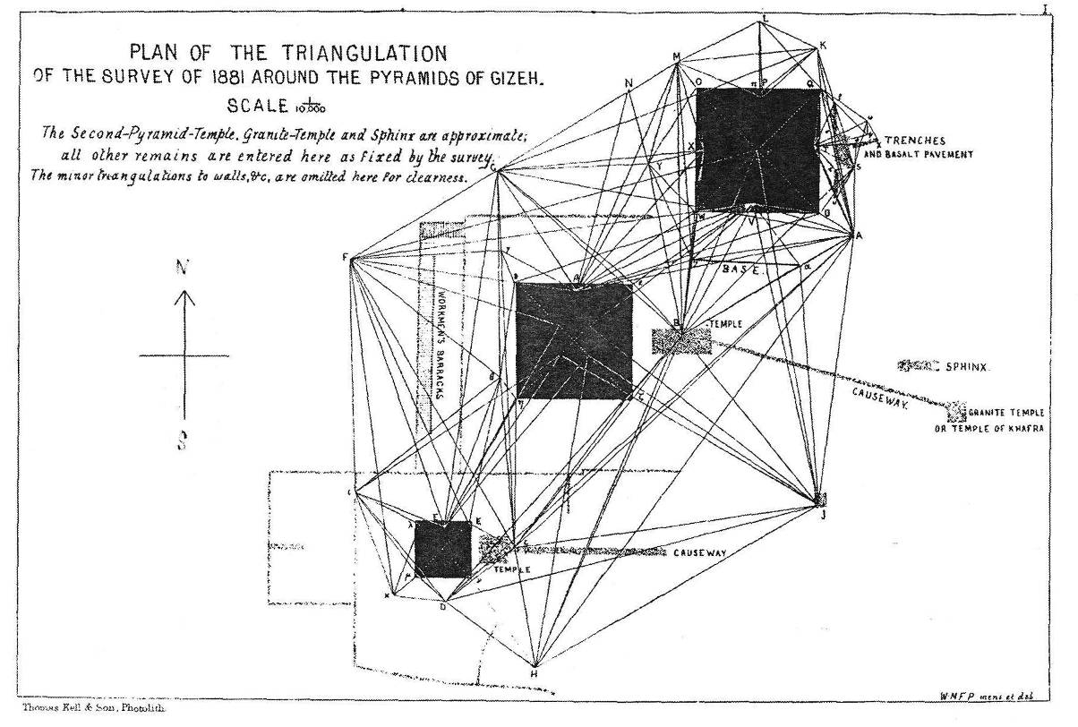

Figure 1: Petrie’s survey plan for the Pyramids of Giza. Petrie 1883, Plate I.

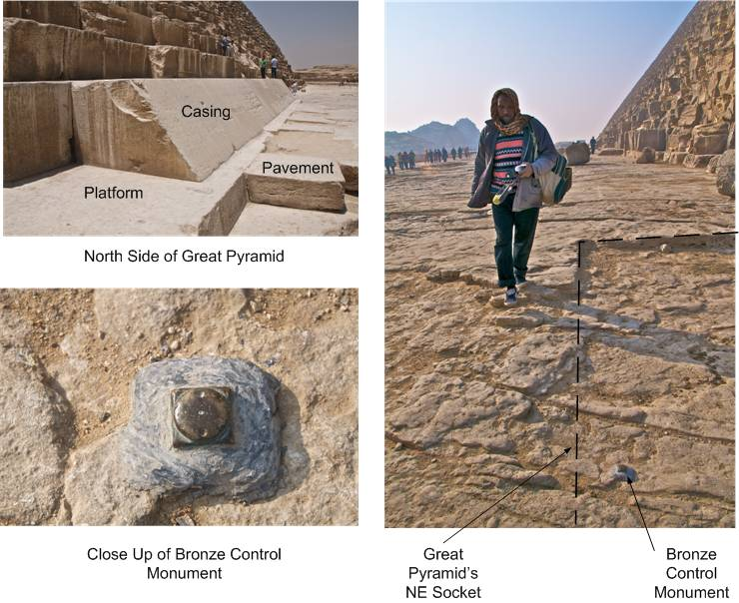

Figure 2: The Great Pyramid was sheathed in sloping casing stones which rested on a limestone platform (upper left). At the corners, the Egyptians cut sockets for oversized platform stones probably used in laying out the base. Just inside the sockets at the NE and NW corners are bronze survey control points set by David Gill in 1874. Photos by Mark Lehner
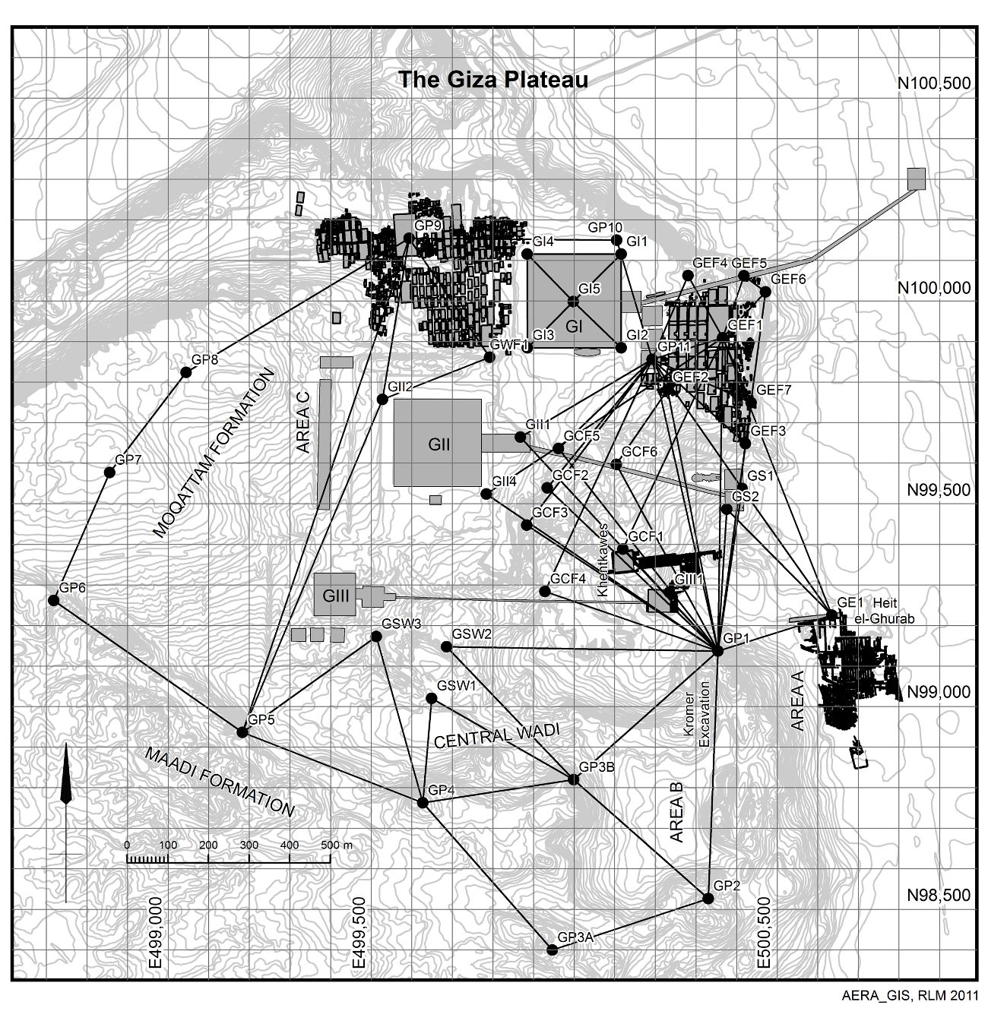
Figure 3: The GPMP control grid for Giza. The dark lines connect the survey control points used in establishing the GPMP grid. The three pyramids of Giza, the Great Pyramid (Khufu), Khafre and Menkaure are designated GI, GII and GIII respectively. Their locations on this map are approximate.

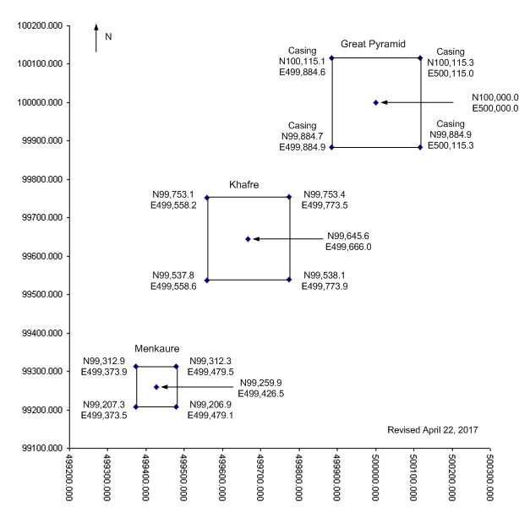

Figure 4: The locations of the pyramids of Giza on the GPMP grid. Locations were derived by the author. Scale in meters.

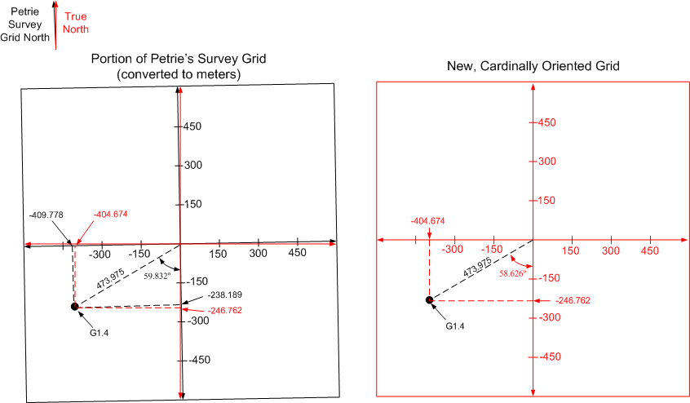

Figure 5: Petrie’s rotated his survey control grid of Giza just over a degree counterclockwise from true north (above, at left). In order to convert his coordinates to GPMP coordinates, I devised a new, cardinally oriented grid (above, at right) to use as an intermediate device. Scale in meters.

See the section of this paper entitled “Revision Notes.”
Petrie 1883.
Petrie 1883, 24. For a definition of probable error see Petrie 1883, xv-xvi.
Petrie 1883, 39
Petrie 1883, 35-6
Petrie stated that the conversion factor was 196.750 units/inch (Petrie 1883, 34). However, if we compare points measured during the GDFS 2015 survey with the same points measured by Petrie, it appears that 196.713 is closer to the correct figure. See Appendix B.
Goodman and Lehner 2007, 53
Goodman and Lehner 2007, 54
Lehner 2012.
Dash 2015.
Petrie places a question mark by this figure. Petrie 1883, 36.
Petrie does not state his probable error for his Khafre and Menkaure corner estimates.
See Appendix B.
Petrie 1883, 34.
Petrie 1883, 205-6
John Legon, who directed my attention to Petrie’s discussion of the comparison between his survey and Watson’s and Gill’s survey, has estimated the conversion factor to be 196.709. Private communication, May 2, 2017.

